**RECURSO**

**A Mini-Project Report**

**Under**

**Project Workshop**

***Submitted by***

**Karan Shah**

**Rahul Sharma**

**ShreyansShingvi**

**Viraj Talaty**

***Under The Guidance Of***

**Prof. Supriya Agrawal**

***in partial fulfillment for the award of the degreeof***

**B.Tech**

**IN**

**Computer Engineering**

**at**



**2013-2014**

**CERTIFICATE**

This is to certify that the project entitled “ReCurso” isthe bonafide work carried out by Karan Shah, Rahul Sharma,ShreyansShingvi&VirajTalaty of B.Tech (Computer Engineering), MPSTME (NMIMS), Mumbai, during the VI semester of the academic year 2013-14, inpartial fulfillment of the requirements for the award of the Degree of Bachelors of Technology as per the norms prescribed by NMIMS. The mini-project work has been assessed and found to be satisfactory.

___________________

Prof. Supriya Agrawal

Internal Mentor

_______________________ ________________________

Examiner 1 Examiner 2

________________________

Dean

Dr. S. Y. Mhaiskar

**DECLARATION**

We,Karan Shah-E038, Rahul Sharma-E039,Shreyans Singhvi-E041 &Viraj Talaty-E047 ofB.Tech (Computer Engineering), VI semester understand that plagiarism is defined as anyone or combination of the following:

1. Un-credited verbatim copying of individual sentences, paragraphs or illustration (such as graphs, diagrams, etc.) from any source, published or unpublished, including the internet.
2. Un-credited improper paraphrasing of pages paragraphs (changing a few words phrases, or rearranging the original sentence order)
3. Credited verbatim copying of a major portion of a paper (or thesis chapter) without clear delineation of who did wrote what. (Source: IEEE, The institute, Dec. 2004)
4. I have made sure that all the ideas, expressions, graphs, diagrams, etc., that are not a result of my work, are properly credited. Long phrases or sentences that had to be used verbatim from published literature have been clearly identified using quotation marks.
5. I affirm that no portion of my work can be considered as plagiarism and I take full responsibility if such a complaint occurs. I understand fully well that the guide of the seminar/ project report may not be in a position to check for the possibility of such incidences of plagiarism in this body of work.

|  |  |  |  |  |
| --- | --- | --- | --- | --- |
| Signature |  |  |  |  |
| Name | Karan Shah | Rahul Sharma | ShreyansShingvi | Viraj Talaty |
| Roll No | E038 | E039 | E041 | E047 |

Place:

Date:

**ACKNOWLEDGEMENT**

We would like to express our special thanks of gratitude our Head of Department **Mr.Dhirendra Mishra** who gave us the golden opportunity to do this wonderful project on the topic **Android Programming**, which also helped us in doing a lot of Research and we came to know about so many new things.

We would like to specially thank our mentor **Mrs.Supriya Agarwal** for her un-ending support and her wonderful time to time suggestions. Mam helped us whenever we were stuck anywhere, while we were in the process of making our idea a reality. We are really thankful to each one them.

Secondly we would also like to thank our parents and friends who helped us a lot in finishing this project within the limited time.

We are making this project not only for marks but to also increase our knowledge.

Thank you once again to all who helped us.

**ABSTRACT**

Communication is the way to go for doing anything. Our whole world is built on the basis of interacting with one another. We talk to each other to express our thoughts, exchange ideas, express our emotions. But the basic criteria for communicating are that the two people interacting should know a common language. Generally English is used to interact throughout the world, but still in many countries the local knowledge is necessary. We thought of bridging the gap between the two people and help them learn few languages through our application. Thus the idea generated to build the application.

ReCurso is a language-learning and text translation platform. The service is designed so that, as users progress through the lessons, they simultaneously help to translate words. As of now we have incorporated French, German and Italian courses for English speakers. The app can run smoothly on android 3.0 to Android 4.2.2.

We’ve tried to keep the user interface as simple as possible so that any user can easily learn various languages. As the user is learning he can keep a track of his progress by knowing how much he has completed. We have divided each language into three levels namely basic, intermediate and advanced. Now each levels has different things in store to learn. We start from the basics like learning alphabets and go up to building sentences. ReCurso also helps you learn basics of any language or what we can say as the grammar required to build sentences and address people. ReCurso has in store a verbs, nouns, etc.

ReCurso is all fun and interesting as it has images to keep you gauged to look into it and learn more. Users can also hear the translation in the various languages, so as to make them well versed while speaking also.

**TABLE OF CONTENTS**

|  |  |  |  |  |
| --- | --- | --- | --- | --- |
| CHAPTER NO. | | | TITLE | PAGE NO. |
|  |  | | List of Figures | 7 |
|  |  | | Abstract | 5 |
| 1 | **INTRODUCTION** | | |  |
| 1.1 | | Project Overview | 8 |
| 1.2 | | Hardware Specification | 9 |
| 1.3 | | Software Specification | 9 |
| 2 | **INSTALLATION & SETUP** | | |  |
| 2.1 | | By directly installing the .apk file | 10 |
| 3. | **ANALYSIS & DESIGN** | | |  |
| 3.1 | | System Design | 11 |
| 3.2 | | System Use case | 15 |
| 4. | **PROJECT IN DETAIL** | | |  |
| 4.1 | | Product Perspective | 17 |
| 4.2 | | User Characteristics | 17 |
| 4.3 | | General Constrain | 18 |
| 4.4 | | Assumptions and Dependencies | 18 |
| 4.5 | | Features | 18 |
| 4.6 | | Graphical User Interface | 20 |
| 5 | **CONCLUSION & FUTURE SCOPE** | | |  |
|  | 5.1 | Conclusion | | 28 |
|  | 5.2 | Future Expansion | | 29 |
| 6 | **REFERENCES** | | | 30 |

**LIST OF FIGURES**

|  |  |  |  |  |  |
| --- | --- | --- | --- | --- | --- |
| CHAPTER NO. | | | TITLE | PAGE NO. | |
| 2 | INSTALLATION & SETUP | | | | |
|  | Fig 2.1.1 ReCurso Special Access | | | 10 |
| Fig.2.1.2 Installing | | | 10 |
| Fig.2.1.3 ReCurso Installed | | | 10 |
| 3 | ANALYSIS & DESIGN | | | | |
|  | | Fig 3.1.1 System Architecture | 11 | |
| Fig 3.1.2 Application Sections | 12 | |
| Fig 3.1.3 Lets Learn Sections | 13 | |
| Fig 3.1.4 Lets Translate Sections | 14 | |
|  | | Fig 3.2.1 System Use Case | 15 | |
|  | | Fig 3.3.1 System Data Flow | 16 | |
| 4 | PROJECT IN DETAIL | | | | |
|  | | Fig 4.6.1 Start Page | 20 | |
| Fig 4.6.2 Select Language | 20 | |
| Fig 4.6.3 Select Level | 21 | |
| Fig 4.6.4 Basic Page | 21 | |
| Fig 4.6.5 Alphabets | 22 | |
| Fig 4.6.6 Numbers | 22 | |
| Fig 4.6.7 Days | 22 | |
| Fig 4.6.8Months | 22 | |
| Fig 4.6.9 Intermediate | 23 | |
| Fig 4.6.10 Advanced | 23 | |
| Fig 4.6.11 Selecting | 23 | |
| Fig 4.6.12 Lang-to-eng | 23 | |
| Fig 4.6.13 Eng-to-lang | 23 | |
| Fig 4.6.14 Sound-to | 23 | |
| Fig 4.6.15Conversation | 24 | |
| Fig 4.6.16 Quiz | 25 | |
| Fig 4.6.17 Translate | 25 | |
| Fig 4.6.18 Word Translate | 25 | |
| Fig 4.6.19 Sentence Translate | 25 | |
| Fig 4.6.20 Settings | 26 | |
| Fig 4.6.21 Instruction1 | 26 | |
| Fig 4.6.22 Instruction2 | 26 | |

1. **INTRODUCTION**

**1.1 Project Overview**

ReCurso is an application which will run on an android powered device. The basic motto of building this application is to educate and make people learn new and different languages. The application is divided into two parts the language trainer known as ‘Lets learn’ and a language translator known as ‘Lets Translate’.

The language trainer facilitates basically three languages, French, German and Italian. Now each language is broadly divided into three levels or stages we can call them. With each stage the difficulty level increases.

In the basic level, ReCurso helps you learn the alphabets, few words and phrases that we use on a day to day basis. IN this level the person is also taught various numbers and days of the week. The user is also able to know and learn the exact pronunciation of each word and number.

Coming to the intermediate level, the user is well versed with basics, so now we teach him words from the category like people, colors, room in an interactive way. By interactive way we mean that there are four different ways/games by which we make the user remember that words. People and color and room, can help the user know things around him happening and talk to people with all the articles and adverbs etc. needed.

In the advanced level we teach the user more advanced words and some basic conversations which will help the user. We expect the user to fluently converse with other in that language. In advanced we’ve made it a point that the user learns all the basic which he/she can use when they fly to the country and interact with people around there.

Over the years we’ve learnt that just by learning a person doesn’t understand and grasp things. He needs to be tested on the same things so as to make him realize how much he has learnt and how much more he has to know. We also provide a quiz section which the user can take advantage of and test his knowledge of that particular language. At the end of the quiz you get a points tally of how much one has learnt.

ReCurso boasts of a peculiar feature that while the user is learning, the application tells him that how much learning has been done and how much remaining. In a way keeping the user up to date with what he has learnt till now.

The second section is the language translator. We’ve put this section because learning the complete language through the app would have been difficult and monotonous. So if the user wants to know something more and wants to translate a particular sentence which he wants to speak in that language, he can make use of this. The basic criteria throughout the application are that he should know English basically so as to learn and understand it better.

We make use of the SQLite database to store and retrieve all the words which are required in the language trainer and words translation part.

ReCurso throughout the application has simple yet interesting design. We’ve tried to use light colors and add images so as to make the user feel interacted and keep him glued to our application.

**1.2 Hardware Interface**

ReCurso is intended as a mobile application for the Android platform and hence is solely supported on Android-powered mobile devices/tablets. We are using Akash tablet to run our application. A memory space of 30mb is required to install and run the application.

**1.3 Software Interface**

The ReCurso application is to be developed under the Android operating systems using the Java JDK (Java Development Kit) and the Android SDK (software development kit) tools.ReCurso is being developed specifically for Android 3.0 (HoneyComb) and all versions released after it. So to run the application we need a mobile phone/tablet which has the specified android version.

The device on which the application is to installed needs to have a software which supports viewing PDF’s as some modules of our application makes use of the PDF viewing software.

**2.INSTALLATION & SETUP**

**2.1 By directly installing the .apk file**

1. The user will need to place theReCurso.apkin the phone memory or SD card of the phone.
2. Then double click on the ReCurso.apk file
3. The user will be shown a list of all the special access that ReCurso will need.

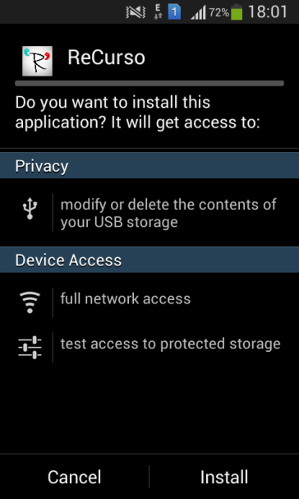

*Fig 2.1.1 ReCurso*

*Special Access*

1. If the user allows ReCurso to make use of this special access then ReCurso will be installed on the user’s device.

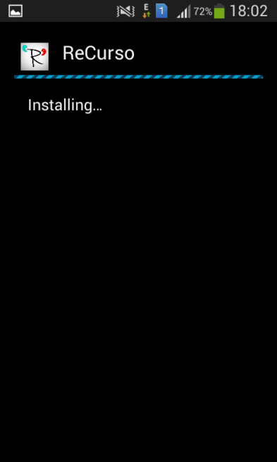 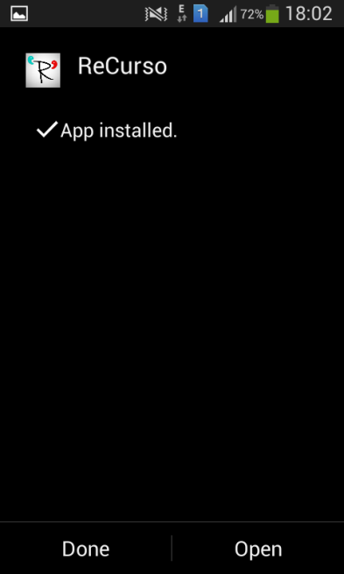

*Fig.2.1.2 Installing Fig.2.1.3 ReCurso Installed*

**3. ANALYSIS & DESIGN**

**3.1 System Design**

*Fig 3.1.1 System Architecture*

The architecture used for this program is a 3 tier architecture.Three-tier (layer) is a client-server architecture in which the user interface, application logic and data storage and data access are developed and maintained as independent modules or most often on separate platforms. Basically, there are 3 layers, tier 1 (presentation tier, GUI tier), tier 2 (application logic tier) and tier 3 (data access tier). These tiers can be developed and tested separately.

What is the need for dividing the code in 3-tiers? Separation of the user interface from business logic and database access has many advantages. Some of the advantages are as follows:

* Reusability of the application logic component results in quick development.
* Transformation of the system is easy. Since ReCurso’s logic is separate from the data access layer, changing the data access layer won’t affect ReCurso’s logic module much.
* Change management of the system is easy. Let's say if there is a minor change in the game logic, we don’t have to install the entire system in individual user’s PCs.
* Having separate functionality servers allows for parallel development of individual tiers by application specialists.
* Provides more flexible resource allocation.

In the initial stage we started building the graphical user interface. We had to start the GUI first because without the GUI we wouldn’t have been able to implement the application logic. Once the GUI was made we started making the application logic and database simultaneously

*Fig 3.1.2Application Sections*

The two main modules of the application is the Lets-Learn and the Lets-Translate module. The lets learn module is the part where the application helps the user to learn words and phrases of that specific language the user wants to learn. The lets-translate module helps the user translate words and sentences from one language to another.

The other 2 modules are Settings and Instructions

The settings section will help the user set the background color. The instructions section will provide the information about what the application is and how to go about it.

The Lets Learn module is design in the following manner

*Fig 3.1.3Lets Learn Sections*

Firstly the lets learn module is further divided into 4 parts namely:

Basics- This section will provide the user with very basic information about the words pronunciations and very basic word category.

Intermediate- This section has various different categories of words like colors, people, room and etc. To make the user remember these words there are various interactive games through which the application will try to make the user remember those words and their pronunciations.

Advanced- The advanced section will teach the user more advanced words. This section also has interactive games same as in the intermediate level. Another feature of this section is that it will teach the user how to get into a conversation if someone and how to go about it.

The quiz section will provide the user with multiple choice questions which the user have to answer. The result of the test will be provided at the end of the test. This section helps the user test his knowledge about the language.

The Lets-Translate is divided in to two parts

*Fig 3.1.3Lets Learn Sections*

In translating words section the user can translate an English word into French/German or Italian as per his wish. The user can even listen to the pronunciations of the word.

In translating sentences if the user wants to translate sentence he will be directed to a website where he can translate the sentence.

**3.2 SYSTEM USE CASE**

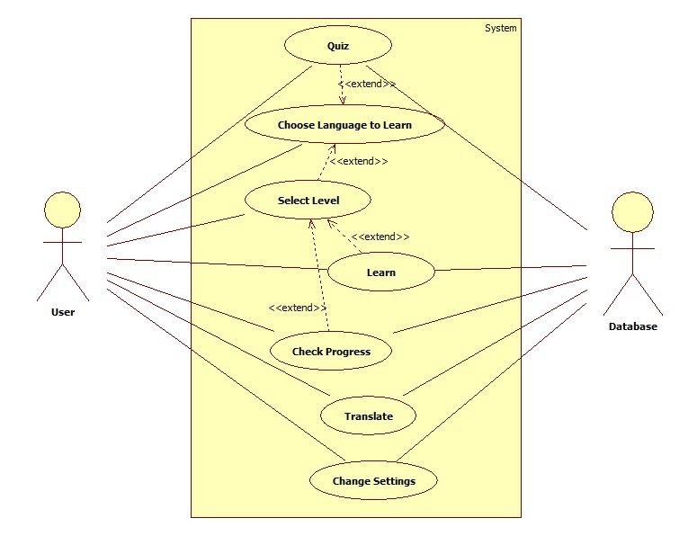

*3.2.1 System Use Case*

There will be two actors interacting with the application the user and the database.

The user will be able to avail all the functions of the application.

The Database will contain all the words for translation, the words which are to be provided for learning and user progress.

**3.3 DATA FLOW DIAGRAM**

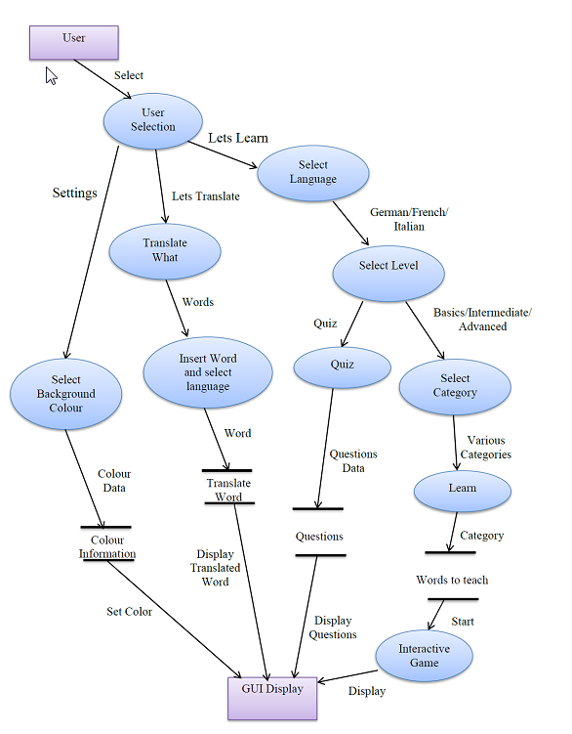

*3.3.1 System Data Flow*

**4. PROJECT IN DETAIL**

**4.1 Product Perspective**

The application consists of two parts: language trainer and a language translator. The language trainer will help the user to learn new languages like French, German and Italian, and the language translator will help to translate sentences from one language to another.

The language trainer will help the user to learn a single language or multiple languages at the same time. The application will present new words and phrases in various levels that increase with complexity with increase in each level. A database will be used to store the meanings of words and phrases and will help the user to get the meaning of the word or a phrase. The only prerequisite is that the user must know one of the English before learning a new language.

The language translator will help the user to translate a sentence or a word or a phrase to another language. The translator will require a large database with all the word associations and correct grammar between the words. Since the words could be translated in multiple languages, the database containing them will be a quite large one and in turn increase the size of the application.

**4.2 User Characteristics**

There are three types of users that will interact with the application: users that want to learn a new language, users that want to translate something from one language to another and administrator.

Each of these three types of users has different use of the system so each of the users have their own requirements.

* Users looking to learn a new language can learn one or multiple languages at once and give tests to check their knowledge about that language.
* Users can repeat levels and tests multiple times.
* Users that what to translate can translate basic everyday sentences from one language to another provided inside the application.
* Administrators can monitor the user’s progress and also design the tests for further levels and also add more complex words or phrases in the later levels.

**4.3 General Constraints**

The only constraint of this application is that it requires a huge space on the phone as it has a huge database containing all the language grammar and word associations.

**4.4 Assumptions and Dependencies**

The assumption is that the phones in which the application is used will have enough memory to store and run the application.

Another assumption is that the user knows English.

**4.5 Features**

1. Data abstraction –Our application has a very large database so how the information is retrieved from the database and how the data is stored in the database is hidden from the user.

2. Simple GUI –The user interface is very simple so any user even new to android system can make use of the application and take advantage of it.

3. Accuracy- all the words and sentences provided by the application are taken from trusted sources and is very accurate.

4. Learning Languages- The application provides the user with the opportunity to learn words and phrases of three different languages that is German, French and Italian.

5. Proper Learning Partitions – The learning levels are divided into 3 parts namely Basics, Intermediate and Advanced. So the user can go step by step increasing his knowledge about the language.

6. Visual Learning- All the words that the application tends to teach the user is supported by images. The images make the application more attractive and also motivate the user to learn new words.

7. Audio Learning- All the words in the application are provided with the real world pronunciation of that word. This feature helps the user to know the real pronunciation of the word which will really help the user.

8. Text to speech –This feature is to support the audio learning feature. The text is converted to the real world pronunciation using androids operating systems Text-To-Speech (TTS) feature.

9. Interactive learning – To make the user understand and remember the words in specific language the application provides the user with interactive learning sessions.

10. Progress- The user will be able to keep a tract of his performances in the various sections of the leaning stages. This will help the user to evaluate his knowledge about that language.

11. Offline Translation- The user will be able to convert few words from English to French, German or Italian according to their wish. To use this this feature they will not need an internet connection as these words will be retrieved from our database.

12. Online Translation- To translate words and sentences which are not stored in the database the user will be directed to a website where he can translate the words/sentences. To take advantage of this feature he will need an internet connection.

13. Instructions- The application is provided with a complete guide of instructions which will guide/tell the user about how the application works and how to go about working with the application to make the most of it

14. SQLite Database- SQLite Database is used for retrieving and storing data from the database.

**4.6 Graphical User Interface**

The GUI is kept as simple as possible so even a user who is new to android system can take advantage of this application.

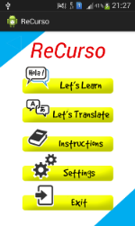

*Fig 4.6.1 Start Page*

This is the GUI of the start page of the application. It has five options Lets-Learn, Lets-Translate, Instructions Settings and Exit. Each of the options will open a new section of the application to the user.

On choosing Lets Translate user will be directed to this page.



*Fig 4.6.2Select Language*

The user will need to select the language which he wants to learn. On selecting a language the user will be directed to the next page.

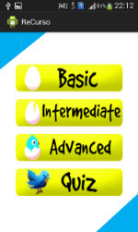

*Fig 4.6.3Select Level*

This page will be displayed after selecting a particular language. The user will need to select the difficulty of learning which he wants to learn. According to the difficulty level selected the application will open the next activity page. The user can even choose the quiz section and test his knowledge about the language.

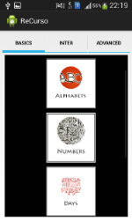

*Fig 4.6.4Basic Page*

This is the UI of the basic section. It has various sections as alphabets, numbers, days and months. The use can select any of the section which he wishes to learn.

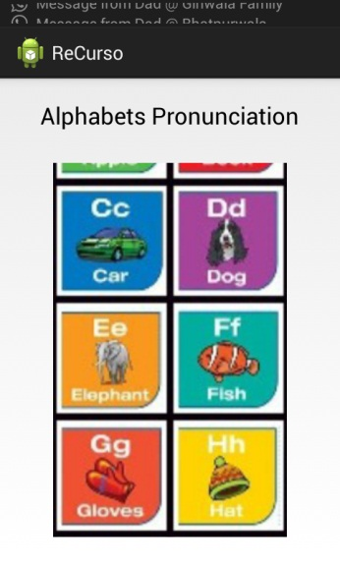

*Fig 4.6.5Alphabets*

On choosing alphabets this is the page where the user will be directed. The user can click on the alphabets and know the pronunciations of the words.

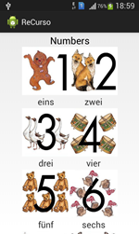 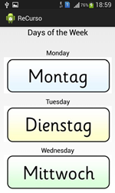 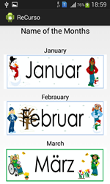

*Fig 4.6.6Numbers Fig 4.6.7Days Fig 4.6.8Months*

These are the layouts of the pages Numbers, Days and Months respectively. The user can press on the images to know the pronunciations of the words.

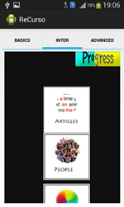 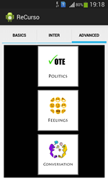

*Fig 4.6.9Intermediate Fig 4.6.10Advanced*

The intermediate section and the advanced level have various levels. On selecting one of the sections to learn the user will be directed to an interactive session. The user can even check his progress which he has made in the various sections of the intermediate level.

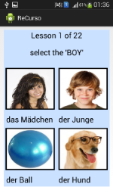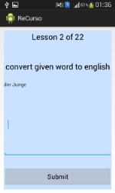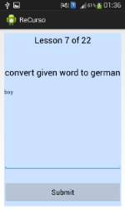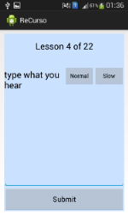

*Fig 4.6.11Selecting Fig 4.6.12lang-to-eng Fig 4.6.12eng-to-lang Fig 4.6.13sound-to*

There are four interactive games which will help the user learn the words.

The selector game - The user will be provided with four picture images to select the correct image.

Word translate- The user will be provided with English word to translate it to the selected language or vice-versa.

Sound translate- The user will be given an option to listen to the pronunciation of the word and then type the word in the selected language. There will be an option to listen to the pronunciation in normal speed or slow speed.

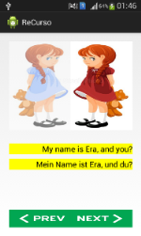

*Fig 4.6.14Conversation*

In the advanced level there is a section called conversation. The conversation section has two buttons next and previous. On pressing it the next/previous statement in the conversation will be displayed. The conversation page shows both the English version and the language version of the statement.

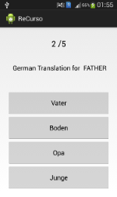

*Fig 4.6.15Quiz*

The quiz section has multiple choice questions which the user has to answer. There will be many questions asked to the user and then the result of the quiz will be shown at the end of the quiz.

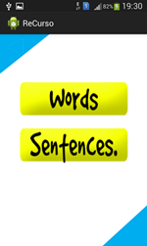

*Fig 4.6.16Translate*

The translate section has two options from which the user can choose from. Translate words and translate sentences

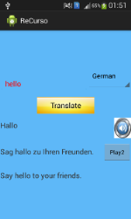 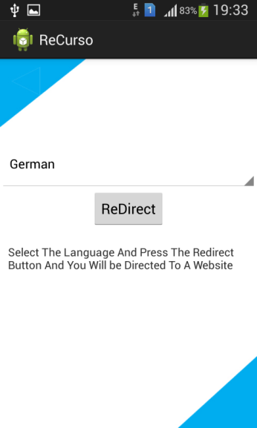

*Fig 4.6.17Word Translate Fig 4.6.18Sentence Translate*

In word translation the user will need to type the word which he wants to translate then select the language into which he wants to translate from the dropdown menu. The translated word will be displayed on the screen. Even a sentence in English and the selected language will be displayed to the user.

In sentence translation the user will need to select the language he wants to translate the English sentence into and then he will be directed to an online website where he can translate the sentence.

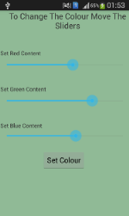

*Fig 4.6.19Settings*

There will be three sliders on the screen. The user will need to slide the sliders and on moving them the background color will change. On selecting ‘set colour’ the background colour displayed on the screen will be set as the background colour for the interactive games section in intermediate and advanced.

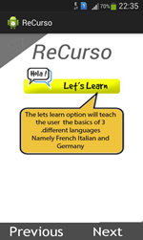 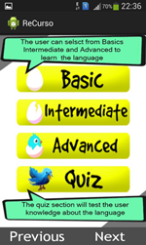

*Fig 4.6.19 Instruction1 Fig 4.6.19 Instruction2*

The instructions part has screenshots of the application with explanatory text bubbles to help the user know about the application.

**5. CONCLUSION & FUTURE SCOPE**

**5.1 Conclusion**

Android is the platform for most of the mobile devices in many countries around the world. It's the largest installed base of any mobile platform and growing fast. Every day many people are buying new android phones and tablets and download games, applications for the device. Android provides platform to create games and applications for the Android phones and can distribute it through play store.

As Android is becoming more popular in the current era and has captured the major smartphone market demanding rapid growth in application development, and due to its open source platform it is easy for developers to develop new applications on this platform to satisfy current user needs. It has all the features that a developer requires to create the best applications. In the current era, most of the mobile companies are manufacturing smartphones and tablets on the Android platform which is used by hundreds of millions of users nowadays motivating the developers to create new applications on the Android platform.

Smartphones offer a lot of functionalities but we cannot deny that the primary reason for buying a phone is to communicate. The application we built over last few months is basically for a user to learn new languages. RECURSO helps you understand the basically three languages and boasts of various levels so as to have better understanding of the language. The application also has a quiz, with its help the user can know its progress in learning the language. We have also provided a functionality where the user can keep a track of his/her progress during the learning phase. Second major feature provided is that the user can actually translate a given sentence into the language of his choice. This feature enables the user to explore the minute details of the language.

**5.2 Future Expansion**

As the technology emerges, it is possible to upgrade the system and can be adaptable to desired environment. It is not possible to develop a system that meets all the requirements of the user. User requirements keep changing as the system is being used. Many future enhancements can be done with the changing technologies and up gradations.

Many new features can be added to our application such as:

* Addition of new languages.
* Making the application more location friendly.
* Better User Interface
* Make a larger Database so as to help user learn as many words as possible.
* Decreased memory usage of the app on the system memory.
* Direct internet connection between the application and internet.
* Increased customization for the user.
* Better multitasking features

**6.REFERENCES**

[1].https://developer.android.com/reference/android

[2].http://www.vogella.com/tutorials/android.html

[3].http://www.tutorialspoint.com/android/android_sqlite_database.htm

[4].http://www.mkyong.com/android/android-alert-dialog-example/

[5].http://mrbool.com/how-to-insert-data-into-a-sqlite-database-in-android/28895

[6].http://www.androidhive.info/2012/01/android-text-to-speech-tutorial/

[7].http://stackoverflow.com/questions/12889608/how-to-open-pdf-file-in-android-from-the-assets-folder